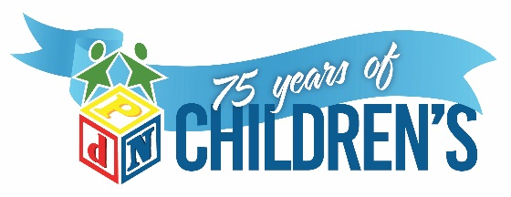

JOB ANNOUNCEMENT - Early Intervention Specialist (EIS)

The mission of PdN Children’s is that we help children with special needs achieve their fullest potential. Our vision is a world where all children thrive in an inclusive environment, recognized by their abilities and talents, rather than their differences. We've been serving children with special needs since 1948 and we love what we do and why we do it! Join us in our mission and make the journey with the precious children we serve.

Job Type: Full-time Salary: $37,440.00 - $49,400.00 per year

Summary/Objective -
Provide Specialized Skills Training services, Evaluation and IFSP Development services to assigned clients as part of an interdisciplinary team.

General Duties

- Provide Specialized Skills Training services to assigned clients in the natural environment, where the child lives, learns and plays.
- Conduct evaluations and IFSP development services to assigned clients as part of an interdisciplinary team.
- Complete all required documentation of Specialized Skills Training services, service coordination evaluations and IFSPs, and transition within designated timelines and according to ECI policy and procedures

Required Education and Experience

- Bachelor’s Degree in Early Childhood Education or related field with 18 hours in related coursework including three hours in child development.
- Certification as a fully qualified EIS Professional in the State of Texas ECI Program.
- Valid driver’s license, CPR and First Aid.

Preferred Education and Experience

- At least two years’ experience working with children under the age of three years and experience working with children having developmental delays or medical diagnosis that qualify for ECI services.
- Experience educating parents on typical child development, as well as, atypical child development, to include providing presentations to families, staff and other community settings.
- Experience working with children diagnosed with or suspected of ASD.
- Experience working with challenging behaviors.

Additional Eligibility Qualifications

- Reliable vehicle to provide Specialized Skills Training for home visits and community settings.
- Must have own cell phone for correspondence and communication with families and other staff.

Language

- English (Required)
- Spanish (Preferred)

Other Duties - Please note this job description is not designed to cover or contain a comprehensive listing of activities, duties or responsibilities that are required of the employee for this job. Duties, responsibilities and activities may change at any time with or without notice.

Work Environment - Work is primarily in the child’s “natural” environment. May provide services via telehealth platform as approved by program director and funding source. Occasional visits to the office may be necessary to turn in paperwork, make copies, fax documents, etc.

Essential Functions - Reasonable accommodations may be made to enable individuals with disabilities to perform the essential functions.

Please submit application (http://pdnchildrens.org/career-opportunities/) and requested documentation to admin@pdnchildrens.org

