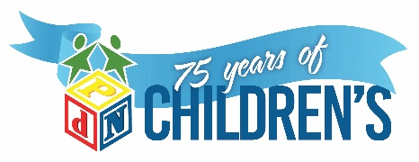

NOW HIRING! PART-TIME Assistant Teacher/INCLUSIVE EARLY LEARNING CENTER
Pay: $10/hr - $13.19/hr D.O.E

The mission of PdN Children’s is that we help children with special needs achieve their fullest potential. Our vision is a world where all children thrive in an inclusive environment, recognized by their abilities and talents, rather than their differences. Join us in our mission and make the journey with the precious children we serve.

Summary/Objective - The Assistant Teacher works together as a team with the Lead Teacher to ensure the health and safety of children with and without special needs. The Assistant Teacher helps in the implementation of learning activities that enhance children’s physical, cognitive, social-emotional and language development.

General Duties
- Maintains compliance with TX Childcare Licensing, Texas Rising Star Standards, and PDNCDC Policies and Procedures.
- Ensure children’s needs are met (including, but not limited to physical needs, emotional needs, etc.)
- Maintain a safe and engaging learning environment, both indoors and outdoors.
- Complete all daily forms & paperwork such as: Daily attendance, health checks, daily reports, medication logs, incident & behavioral reports
- Assisting Lead Teacher in the execution of monthly lesson plans ensuring program curriculum is being implemented
- Maintain confidentiality of children and family information
- Maintain communication with therapists, co-workers, supervisors and parents regarding child’s needs and progress
- Report suspected child abuse and neglect as required by law

Required Education and Experience
- 18 years of age
- High School Diploma or GED

Preferred Education and Experience
- One year experience working in early childhood
- One year experience working with children with special needs
- Bilingual (English and Spanish)
- Early Childhood education credits

Work Environment - Inclusive Classroom and Outdoor Playground

Essential Functions - Reasonable accommodations may be made to enable individuals with disabilities to perform the essential functions.
Please submit application (http://pdnchildrens.org/career-opportunities/), resume, and proof of education to admin@pdnchildrens.org

